
Student Name: Kenan Kiplimo
Admission Number: BSCCS/2025/67071
Course/Class: Bachelor of Science in Computer science
Unit Code: BIT4139
Unit Name: Ethical Hacking and Counter Measures
Lecturer Name: Mr. Michael Nyoro
Semester/Academic Year: Year 3 Semester 2, May 2026

Tools
- Whois
- Ping
- theHarvester
- Nmap

Week 1: Nmap Installation and Scanning 1
Fig 1: NMAP INSTALLATION 1
Fig 2: CONFIRMING INSTALLATION 1
Fig 3: Scanning scanme.nmap.org 1
Fig 4: Scanning an ip address 1
Fig 5: Port Scanning my Wi-Fi router 1
Student Reflection 1
Week 2: Vulnerability Analysis 1
Tools Used 1
Fig 4: Identifying the domain registrar using whois 1
Fig 5: identifying the ip address using ping 1
Fig 6: Using theHarvester to retrieve email information and subdomains 1
Fig 7: Using Nmap to retrieve open ports and running services 1
Fig 8: Checking OS version using Nmap 1
Student Reflection 1

Week 1: Nmap Installation and Scanning

Fig 1: NMAP INSTALLATION
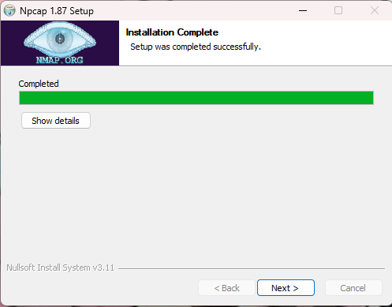

Fig 2: CONFIRMING INSTALLATION
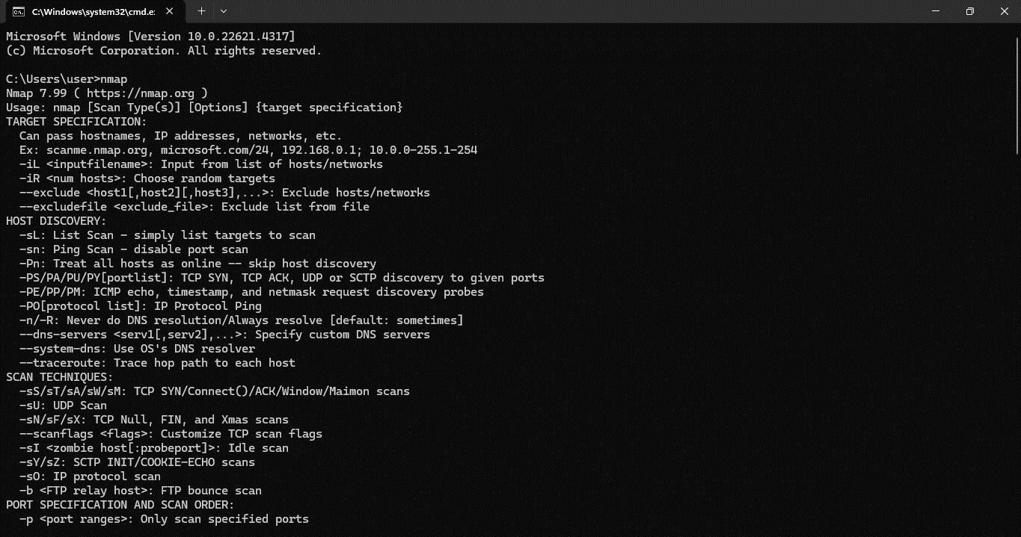

Fig 3: Scanning scanme.nmap.org
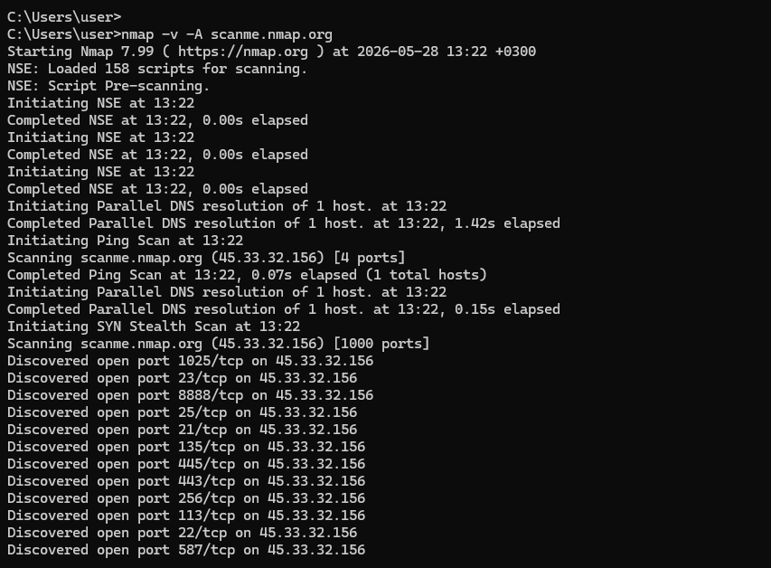

Fig 4: Scanning an ip address

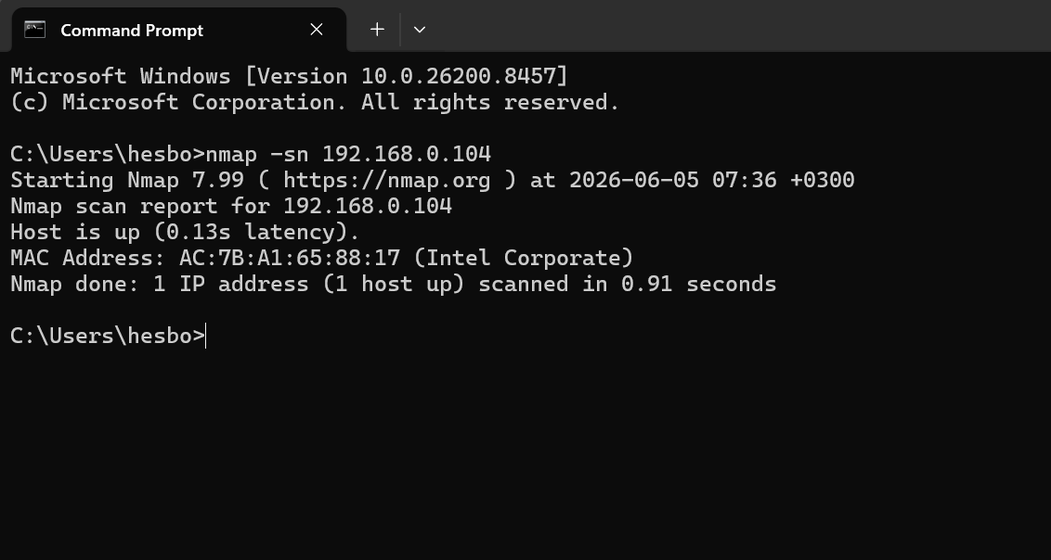

Fig 5: Port Scanning my Wi-Fi router
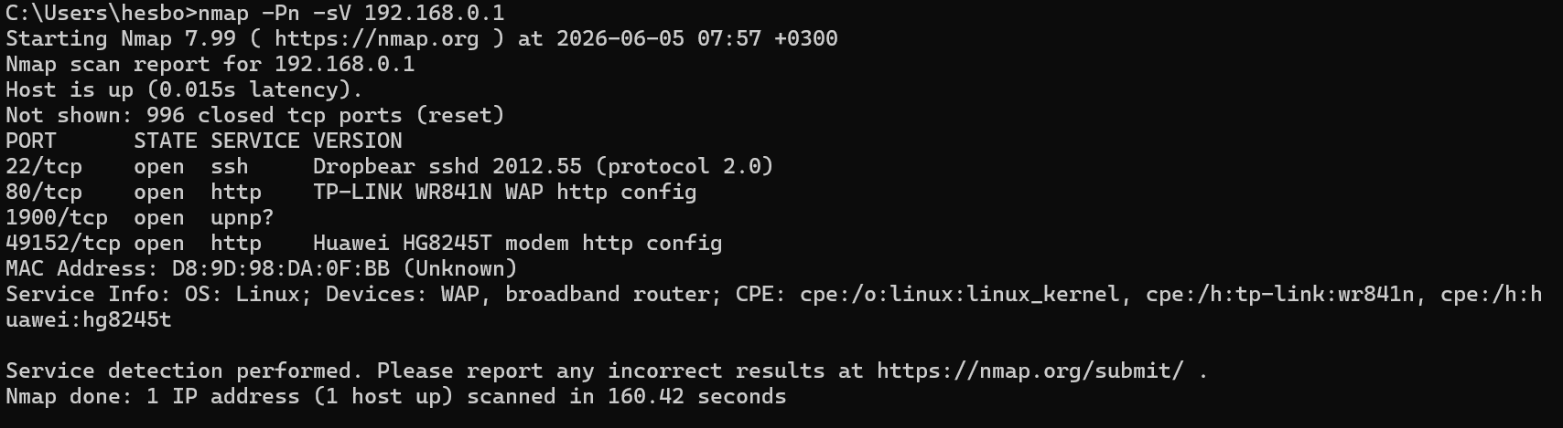

Student Reflection
I downloaded and installed Nmap. I tried checking on the ports and services of my friend’s laptop but it’s firewalls were too strong and the Process returned a blank page. I then used my wifi router as the target and I was able to get some results. Footprinting did not work on the router it returned an empty page.

Week 2: Vulnerability Analysis
Organization Identified: KPLC (kplc.co.ke)

Tools Used
Tool | Objective | Findings
whois | Registrar | Safaricom Limited
whois | Registrar Email | ebt-domain@safaricom.co.ke
ping | Domain IP | 41.80.37.27
theHarvester | Email Patterns | e.g.: cjagongo@kplc.co.ke
theHarvester | Subdomains and their ports | e.g.: analytics.kplc.co.ke - 41.203.223.132
Nmap | Open Ports and Services | Port: 25/tcp  Service: smtp
Nmap | OS version | Failed

Fig 4: Identifying the domain registrar using whois
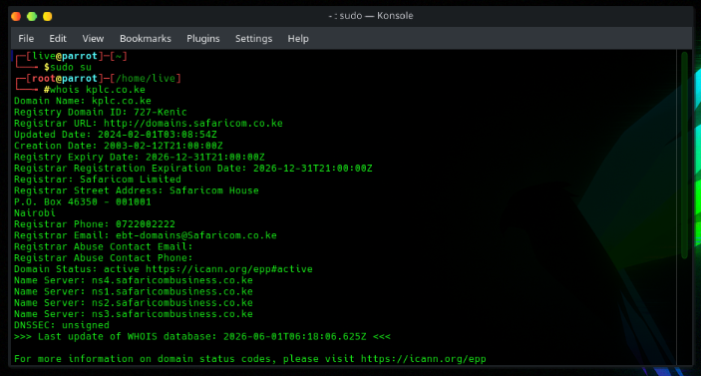

Fig 5: identifying the ip address using ping
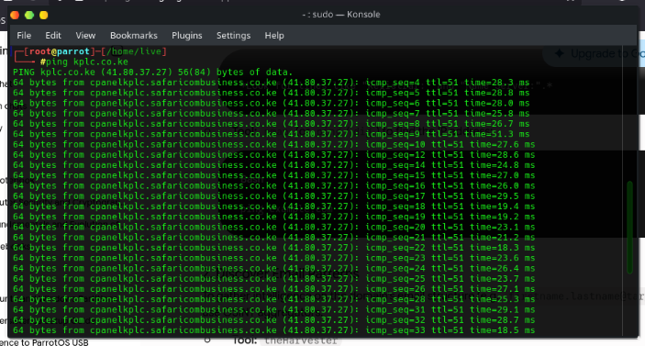

Fig 6: Using theHarvester to retrieve email information and subdomains
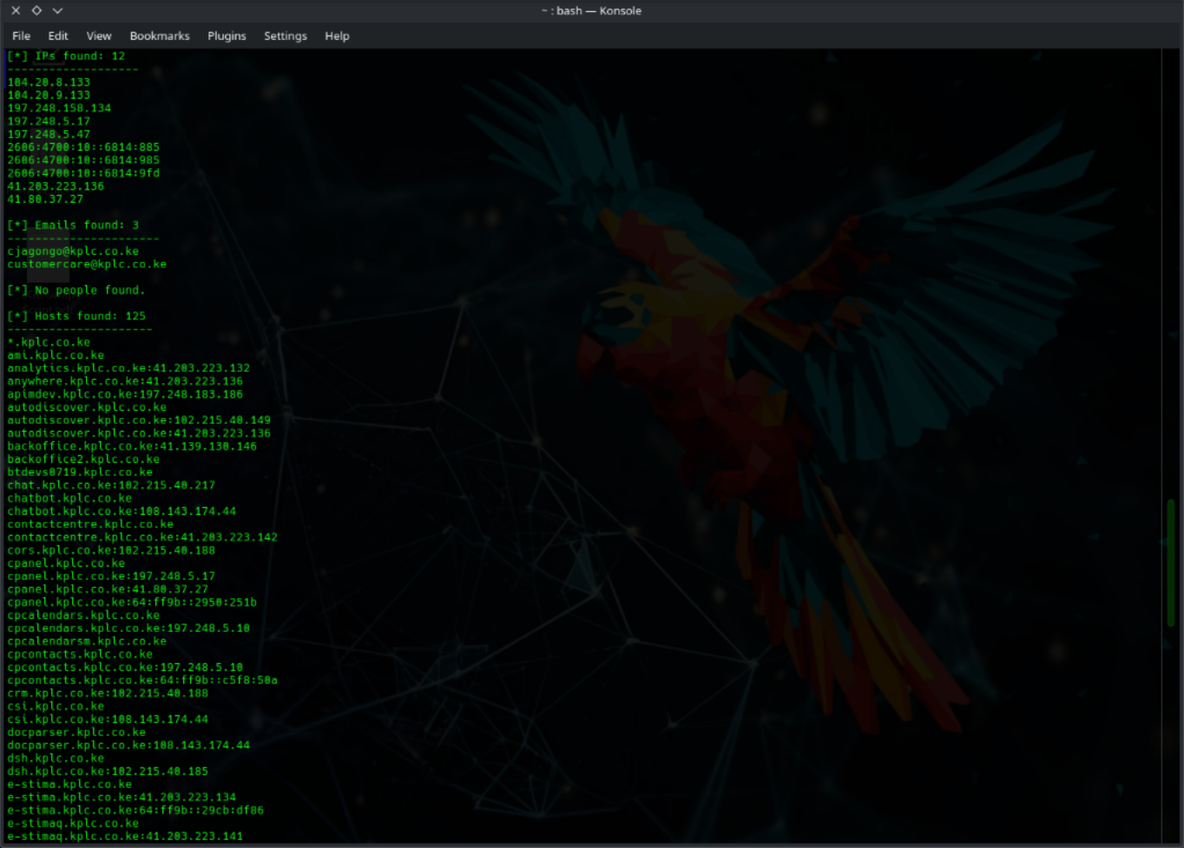

Fig 7: Using Nmap to retrieve open ports and running services
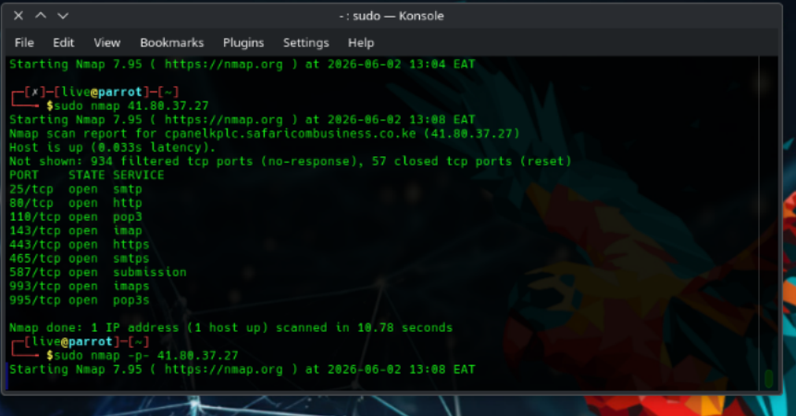

Fig 8: Checking OS version using Nmap
Nmap scan report for cpanelkplc.safaricombusiness.co.ke (41.80.37.27)
Host is up.
All 1000 scanned ports on cpanelkplc.safaricombusiness.co.ke (41.80.37.27) are in ignored states.
Not shown: 1000 filtered tcp ports (no-response)
Too many fingerprints match this host to give specific OS details
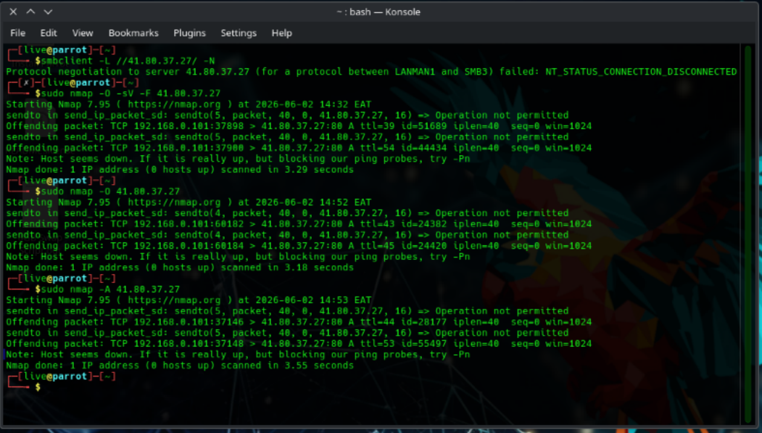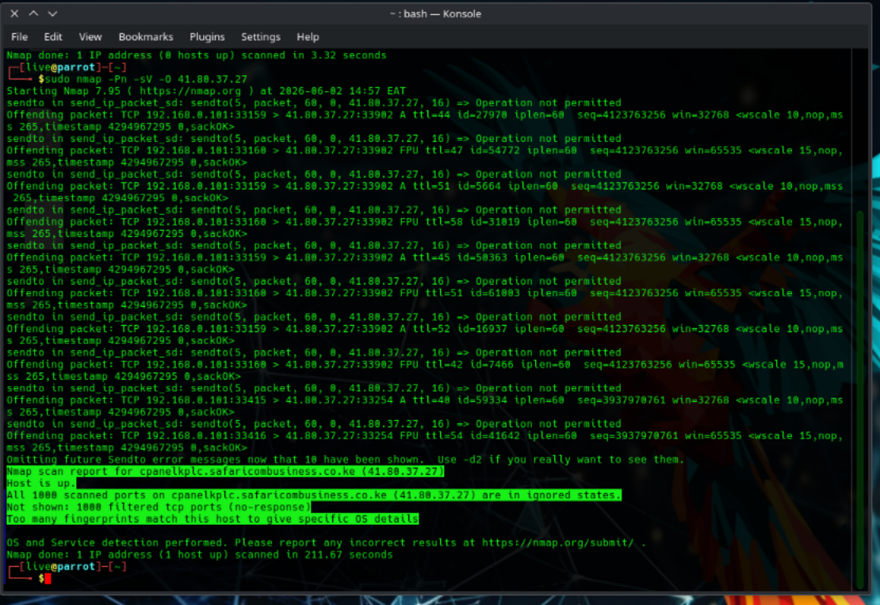

Student Reflection
The target domain was kplc.co.ke. Using whois and ping, I identified the domain registrar and resolved the primary IP address. theHarvester successfully mapped out sensitive internal details, revealing internal email patterns and harvesting 125 subdomains.
Active scanning via Nmap exposed multiple open ports handling mail and web traffic.

